**AI-POWERED NUTRITION ANALYZER FOR FITNESS ENTHUSIASTS**

**PROJECT REPORT**

**submitted by**

**Aniket Panthri**

**Melissa Maria Augustine**

**Dharmapuri Sudheshna**

**Davidson Mahapatra**

**Introduction**

Foods a necessity for human life and has been addressed in numerous medical conventions. Due to the improvement in people’s standards of living, obesity rates are increasing at an alarming speed, and this is reflective to the risks in people’s health. People need to control their daily calorie intake by eating healthier foods, which is the most basic method to avoid obesity. However, although food packaging comes with nutrition (and calorie) labels, it is still not very convenient for people to refer. App-based nutrient dashboard systems which can analyse real-time images of the meal and analyse it for nutritional content can be very handy and improve the dietary habits, and therefore, result in a healthy life.

Modern dietary evaluation and nutrition analysis technologies give consumers more possibilities to explore nutrition patterns, comprehend their daily eating habits, and keep up a balanced diet. Finding out a food's nutritional value is done through nutritional analysis. Information about the chemical makeup, processing, quality assurance, and contamination of food is a crucial component of analytical chemistry.

**Project objective**

The precise and accurate identification of the individual nutrients present in each food item is made possible with the use of a nutrition analyser. Food components have a wide range of bio metabolic processes and may have a negative impact on human health.

The AI-powered Nutrition Analyzer's goal is to aid those who require an appropriate nutrition assistance in achieving fitness goals, treating illnesses with food, or leading healthy lives. A suitable nutrition analyser that can display the nutrient content of food when we provide a picture of it has been made feasible with the use of artificial intelligence.

**Current Issue**

It is advised to consume food in moderation as a prerequisite to being healthy. Controlling a healthy diet involves being aware of how much food is consumed each day and keeping track of its caloric and nutritional content. But there is not the right help to get there. Human growth and health are fundamentally dependent on nutrition, and the consumption of various nutrients and micronutrients can have an impact on health. Disease incidence is influenced by dietary factors, and several diseases are becoming more common as age groups in which they typically manifest are eroding.

For the human body to receive the proper levels of nutrients, a broad range of dietary products must be consumed. It has been demonstrated that not adhering to such a well-balanced diet and leading a generally unhealthy lifestyle increases the chance of developing cardiovascular disease, type II diabetes, and several cancers.

**Problem Statement**

In a perfect world, everyone would have access to a nutrition analyser that would aid in their dietary planning and aid in the maintenance of their health.

People frequently consume food without understanding its nutritional value. This causes a nutritional imbalance, which in turn causes illnesses and deficiencies.

**Solution:**

A simple nutrition analyser that can analyse the nutrients in food by providing a picture of the food is what our project, Nutrition Analyzer for Fitness Enthusiasts, is focused on developing. Artificial intelligence using Python, deep learning, CNN, etc., is used to do this.

**Project method:**

This project is a web application. The web application was developed using python and flask. The project makes use of AI by using CNN for visual recognition to read input from users and deliver its nutritional details. An image recognition AI model is first built. It is then integrated with flask to run the web application.

**PROJECT DESIGN**

**Simplified Data flow:**

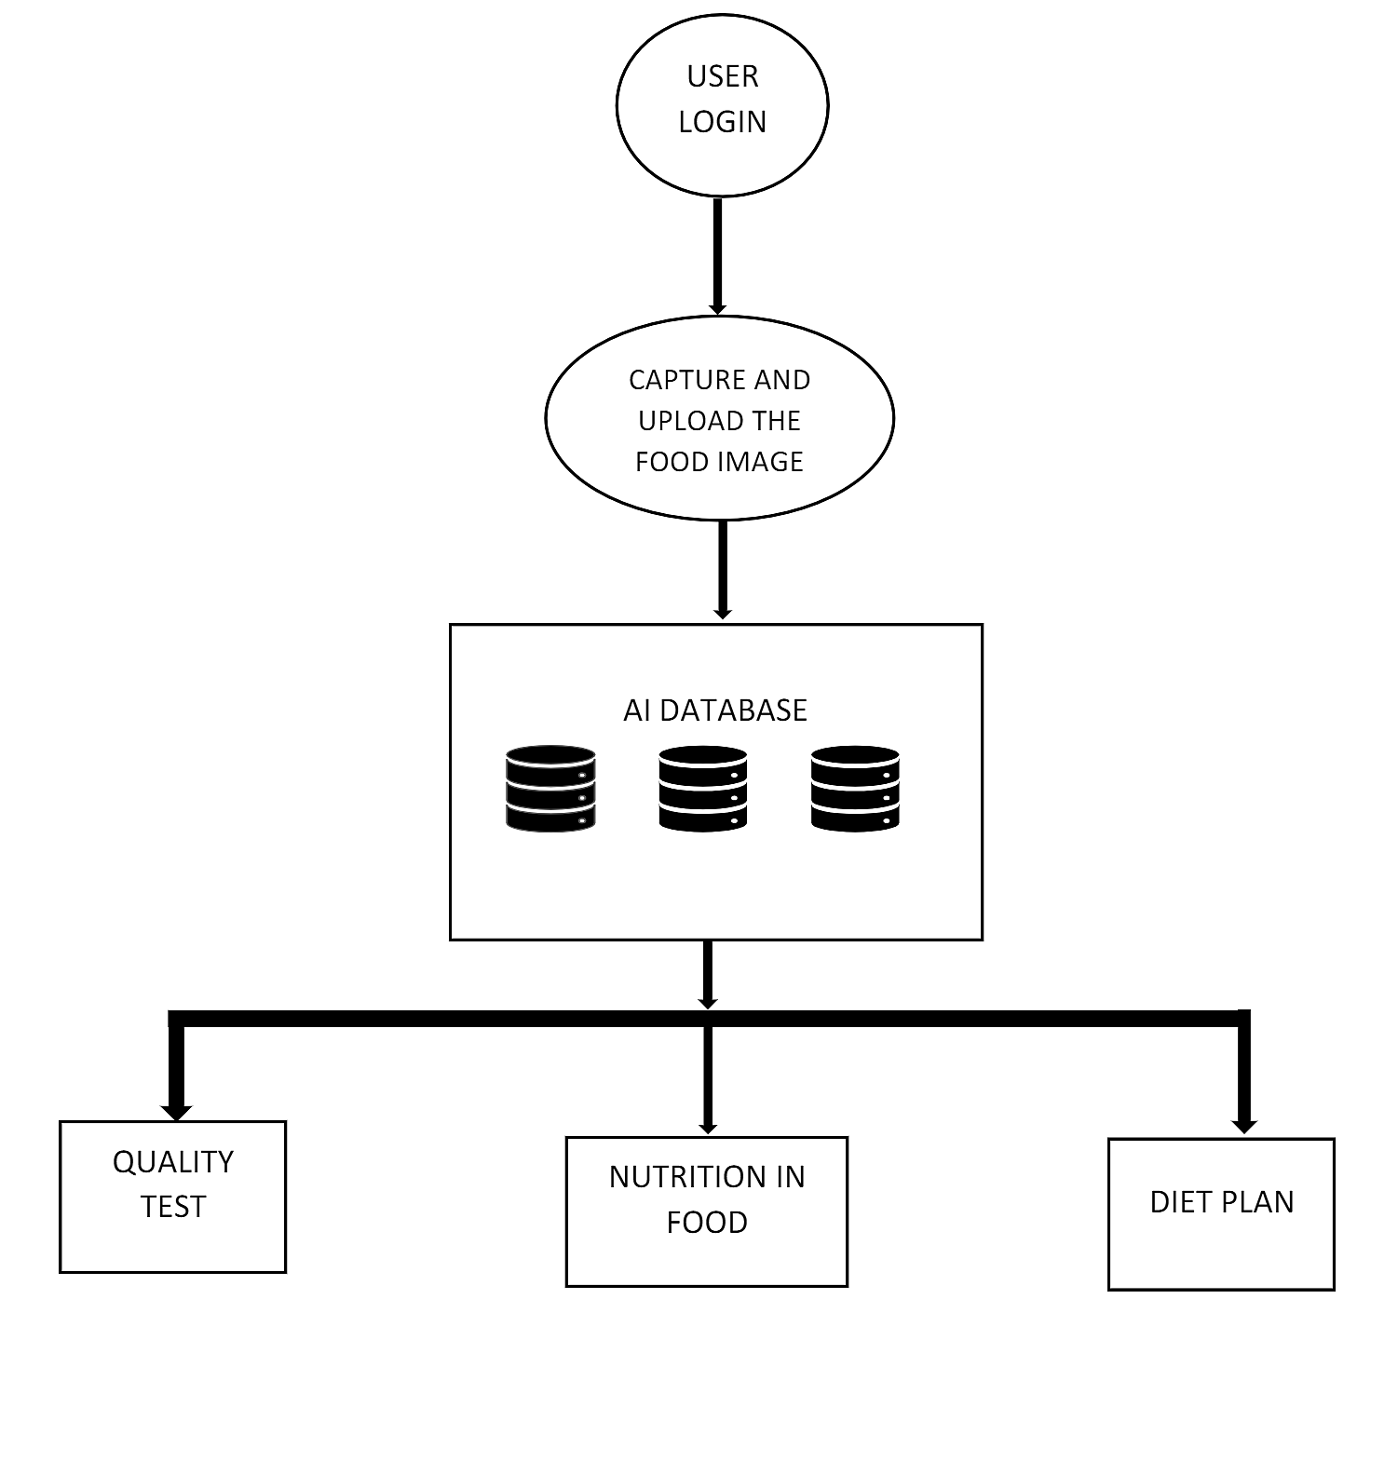

1. The application starts from the user login. The user must enter their mail id and the password to use the nutrition analyser
2. The user can give the input food by uploading an image of the food.
3. The website analyses the input image and gives the nutritional details of the food.

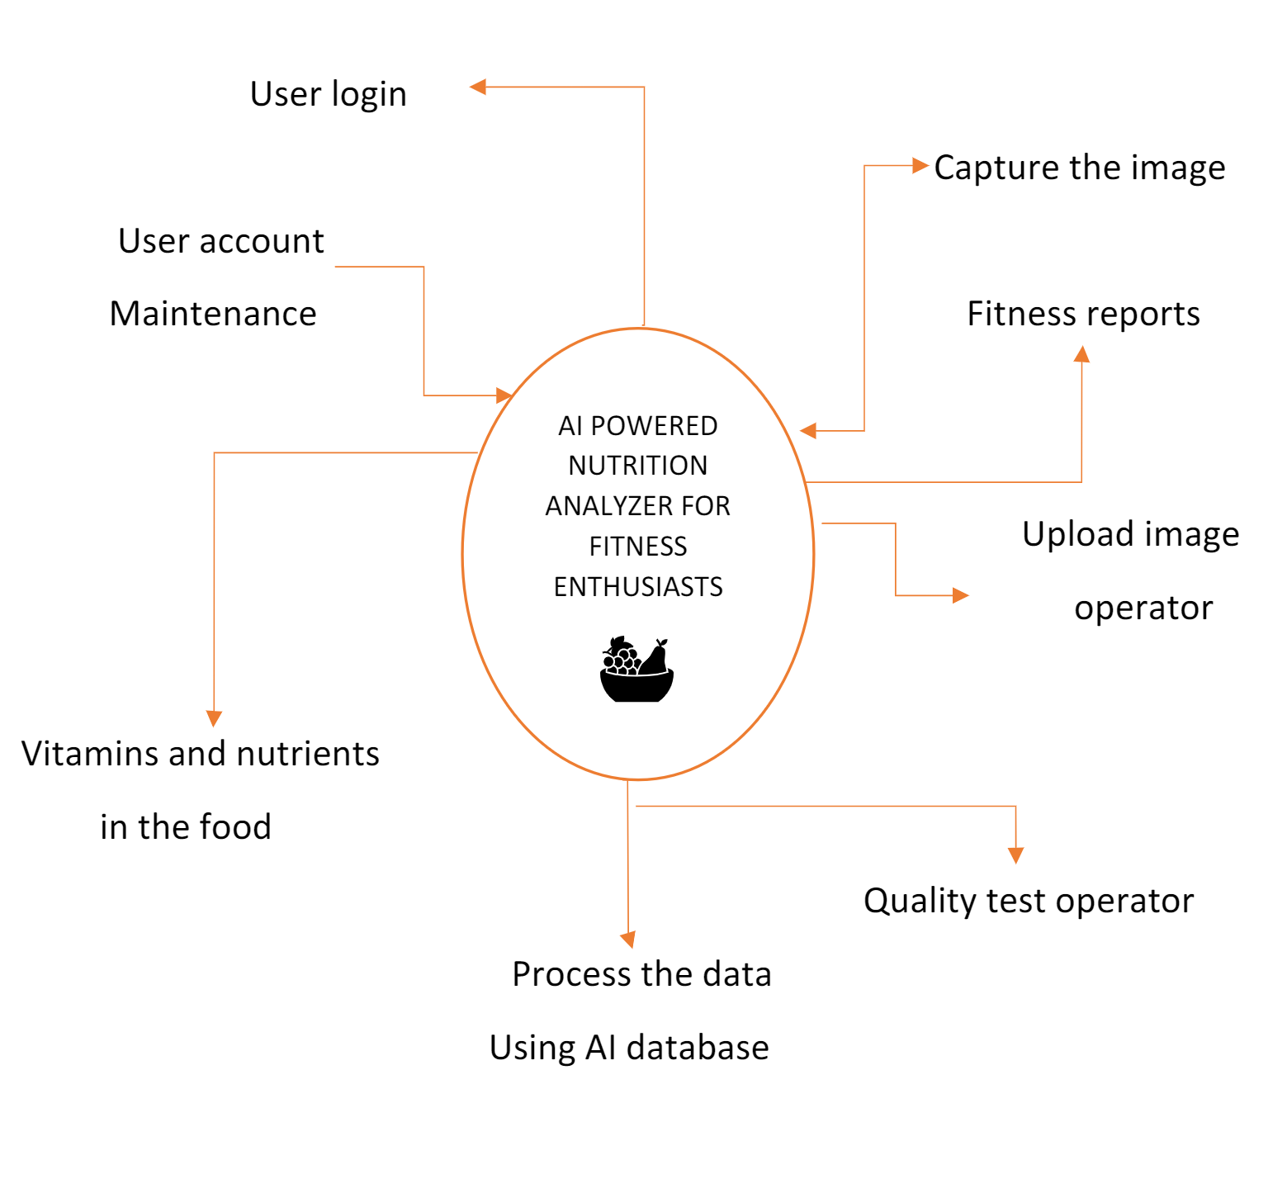

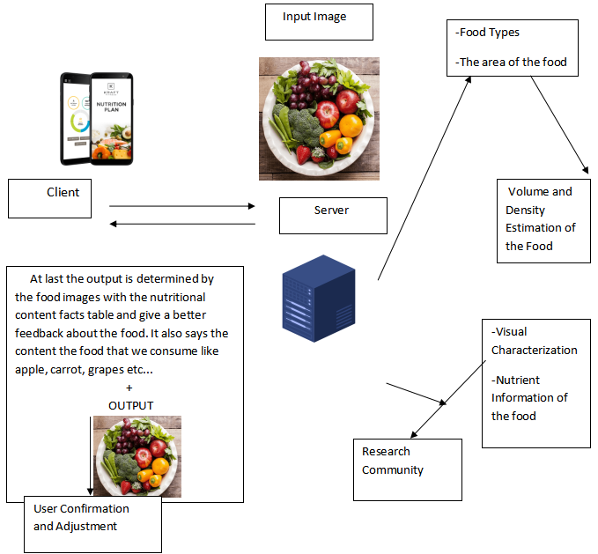

**RESULT:**

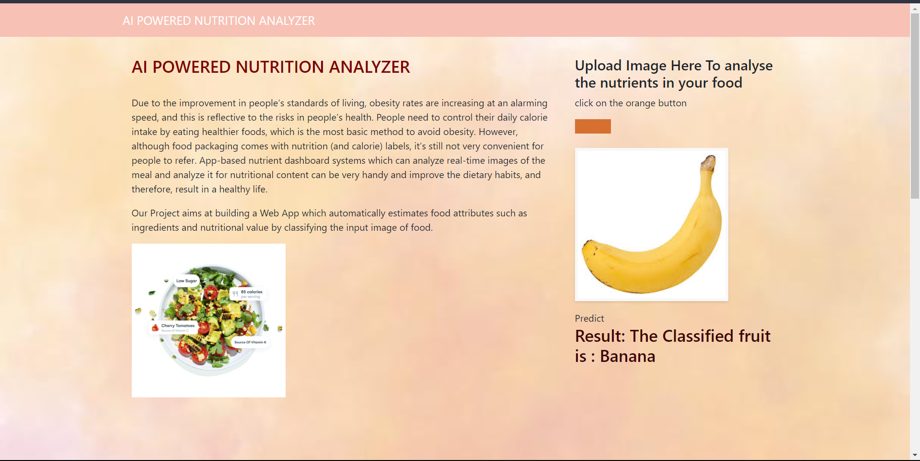

**CONCLUSION:**

To sum up, the development of an AI-based nutrition analyser has the potential to greatly enhance people's eating behaviours and encourage a healthy lifestyle. Having a handy tool for assessing the nutritional value of food is extremely essential given the increasing prevalence of obesity and the necessity for people to monitor their calorie consumption. This project promises to deliver real-time nutritional analysis based on uploaded pictures of meals using artificial intelligence and recognition of image technology.

The project's major purpose is to precisely identify the exact nutrients present in each food item, enabling consumers to make informed dietary decisions. The project seeks to close the knowledge gap between food consumption and nutritional value by providing a user-friendly nutrition analyzer.

**WEB APP LINK:**

The AI nutrition web app can be accessed using the following link:

**CODE FILES:**

**Log.html**

<html lang="en">  
  
<head>  
 <meta charset="UTF-8">  
 <meta name="viewport" content="width=device-width, initial-scale=1.0">  
 <meta http-equiv="X-UA-Compatible" content="ie=edge">  
 <title>Fruit Classification</title>  
 <link href="https://cdn.bootcss.com/bootstrap/4.0.0/css/bootstrap.min.css" rel="stylesheet">  
 <script src="https://cdn.bootcss.com/popper.js/1.12.9/umd/popper.min.js"></script>  
 <script src="https://cdn.bootcss.com/jquery/3.3.1/jquery.min.js"></script>  
 <script src="https://cdn.bootcss.com/bootstrap/4.0.0/js/bootstrap.min.js"></script>  
 <link href="{{ url_for('static', filename='css/main.css') }}" rel="stylesheet">  
 <style>  
  
 .bg-dark {  
 background-color: #f7c1b5!important;  
 }  
 #result {  
 color: #3b0508;  
 }  
 body  
 {  
 background-image: "bgg.jpeg";  
 background-size: cover;  
 }  
  
 </style>  
</head>  
  
<body background="static/css/bgg.jpeg">  
  
 <nav class="navbar navbar-dark bg-dark">  
 <div class="container">  
 <a class="navbar-brand" href="#">AI POWERED NUTRITION ANALYZER</a>  
 </div>  
 </nav>  
 <div class="container">  
 <div id="content" style="margin-top:2em">  
 <div class="container">  
 <div class="row">  
 <div class="col-sm-8 bd">  
 <h3 style="color:maroon">AI POWERED NUTRITION ANALYZER </h3>  
  
 <br>  
 <p> Due to the improvement in people’s standards of living, obesity rates are increasing at an alarming speed, and this is reflective to the risks in people’s health. People need to control their daily calorie intake by eating healthier foods, which is the most basic method to avoid obesity. However, although food packaging comes with nutrition (and calorie) labels, it’s still not very convenient for people to refer.  
 App-based nutrient dashboard systems which can analyze real-time images of the meal and analyze it for nutritional content can be very handy and  
 improve the dietary habits, and therefore, result in a healthy life.</p>  
 <p>Our Project aims at building a Web App which automatically estimates food attributes such as ingredients and nutritional value by classifying the input image of food.</p>  
 <img src="https://whisk.com/wp-content/uploads/2020/10/calculator-tooltips.jpg" height="15%",width="8%">  
 </div>  
 <div class="col-sm-4" >  
 <div>  
 <h4>Upload Image Here To analyse the nutrients in your food</h4>  
 <p>click on the orange button</p>  
 <form action = "http://localhost:5000/" id="upload-file" method="post" enctype="multipart/form-data">  
 <label for="imageUpload" class="upload-label">  
  
 </label>  
  
 <input type="file" name="image" id="imageUpload" accept=".png, .jpg, .jpeg">  
 </form>  
  
  
 <div class="image-section" style="display:none;">  
 <div class="img-preview">  
 <div id="imagePreview">  
 </div>  
 </div>  
 <div>  
 Predict  
 <button type="button" class="btn btn-info btn-lg " id="btn-predict">Predict</button>  
 </div>  
 </div>  
  
 <div class="loader" style="display:none;"></div>  
  
 <h3>  
 <span id="result"> </span>  
 </h3>  
  
 </div>  
 </div>  
  
 </div>  
 </div>  
 </div>  
 </div>  
</body>  
  
<footer>  
 <script src="{{ url_for('static', filename='js/main.js') }}" type="text/javascript"></script>  
</footer>  
  
</html>

**Main.py**

import numpy as np  
import os  
from tensorflow.keras.models import load_model  
from tensorflow.keras.preprocessing import image  
from flask import Flask,render_template,request  
  
app=Flask(__name__)  
model=load_model("animalWeights.h5")  
@app.route('/')  
def index():  
 return render_template("log.html")  
@app.route('/predict',methods=['GET','POST'])  
def upload():  
 if request.method=='POST':  
 f=request.files['image']  
 basepath=os.path.dirname(__file__)  
 filepath=os.path.join(basepath,'uploads',f.filename)  
 f.save(filepath)  
 img=image.load_img(filepath,target_size=(200,200))  
 x=image.img_to_array(img)  
 x=np.expand_dims(x,axis=0)  
 pred=np.argmax(model.predict(x),axis=1)  
 index=['Apples','Banana','Orange','Pineapple','Watermelon']  
 text="The Classified fruit is : " +str(index[pred[0]])  
 return text  
  
if __name__=='__main__':  
 app.run()

**main.js**

$(document).ready(function () {  
 // Init  
 $('.image-section').hide();  
 $('.loader').hide();  
 $('#result').hide();  
  
 // Upload Preview  
 function readURL(input) {  
 if (input.files && input.files[0]) {  
 var reader = new FileReader();  
 reader.onload = function (e) {  
 $('#imagePreview').css('background-image', 'url(' + e.target.result + ')');  
 $('#imagePreview').hide();  
 $('#imagePreview').fadeIn(650);  
 }  
 reader.readAsDataURL(input.files[0]);  
 }  
 }  
 $("#imageUpload").change(function () {  
 $('.image-section').show();  
 $('#btn-predict').show();  
 $('#result').text('');  
 $('#result').hide();  
 readURL(this);  
 });  
  
 // Predict  
 $('#btn-predict').click(function () {  
 var form_data = new FormData($('#upload-file')[0]);  
  
 // Show loading animation  
 $(this).hide();  
 $('.loader').show();  
  
 // Make prediction by calling api /predict  
 $.ajax({  
 type: 'POST',  
 url: '/predict',  
 data: form_data,  
 contentType: false,  
 cache: false,  
 processData: false,  
 async: true,  
 success: function (data) {  
 // Get and display the result  
 $('.loader').hide();  
 $('#result').fadeIn(600);  
 $('#result').text(' Result: ' + data);  
 console.log('Success!');  
 },  
 });  
 });  
  
});

**Main.css**

.img-preview {  
 width: 256px;  
 height: 256px;  
 position: relative;  
 border: 5px solid #F8F8F8;  
 box-shadow: 0px 2px 4px 0px rgba(0, 0, 0, 0.1);  
 margin-top: 1em;  
 margin-bottom: 1em;   
}  
  
.img-preview>div {  
 width: 100%;  
 height: 100%;  
 background-size: 256px 256px;  
 background-repeat: no-repeat;  
 background-position: center;  
}  
  
input[type="file"] {  
 display: none;  
}  
  
.upload-label{  
 display: inline-block;  
 padding: 12px 30px;  
 background: #d67031;  
 color: #fff;  
 font-size: 1em;  
 transition: all .4s;  
 cursor: pointer;  
}  
  
.upload-label:hover{  
 background: #34495E;  
 color: #d67031;  
}  
  
.loader {  
 border: 8px solid #f3f3f3; /* Light grey */  
 border-top: 8px solid #d67031; /* Blue */  
 border-radius: 50%;  
 width: 50px;  
 height: 50px;  
 animation: spin 1s linear infinite;  
}  
  
@keyframes spin {  
 0% { transform: rotate(0deg); }  
 100% { transform: rotate(360deg); }  
}

**REFERENCES:**

Shixin Gu, Joni Chung, Xiang Chen, Deep Learning-Based Food Calorie Estimation Method in Dietary Assessment,2017.